Experiment 12
- Implement echo client server using TCP/UDP sockets
AIM: To Implement echo client server using TCP/UDP sockets
import socket
import threading

HOST = '127.0.0.1'
TCP_PORT = 12345
UDP_PORT = 12346

def tcp_server():
server = socket.socket(socket.AF_INET, socket.SOCK_STREAM)
server.bind((HOST, TCP_PORT))
server.listen(5)

print("TCP Server Started")

conn, addr = server.accept()
print("Client Connected:", addr)

while True:
data = conn.recv(1024)

if not data:
break

message = data.decode()
print("Client:", message)

if message.lower() == "exit":
break

conn.send(data)

conn.close()
server.close()
print("TCP Server Closed")

def tcp_client():
client = socket.socket(socket.AF_INET, socket.SOCK_STREAM)
client.connect((HOST, TCP_PORT))

print("Connected to TCP Server")

while True:
message = input("Enter message: ")
client.send(message.encode())

if message.lower() == "exit":
break

data = client.recv(1024)
print("Server Echo:", data.decode())

client.close()

def udp_server():
server = socket.socket(socket.AF_INET, socket.SOCK_DGRAM)
server.bind((HOST, UDP_PORT))

print("UDP Server Started")

while True:
data, addr = server.recvfrom(1024)
message = data.decode()

print("Client:", message)

if message.lower() == "exit":
break

server.sendto(data, addr)

server.close()
print("UDP Server Closed")

def udp_client():
client = socket.socket(socket.AF_INET, socket.SOCK_DGRAM)

print("Connected to UDP Server")

while True:
message = input("Enter message: ")
client.sendto(message.encode(), (HOST, UDP_PORT))

if message.lower() == "exit":
break

data, addr = client.recvfrom(1024)
print("Server Echo:", data.decode())

client.close()

print("ECHO CLIENT SERVER")
print("1. TCP Server")
print("2. TCP Client")
print("3. UDP Server")
print("4. UDP Client")

choice = int(input("Enter your choice: "))

if choice == 1:
tcp_server()
elif choice == 2:
tcp_client()
elif choice == 3:
udp_server()
elif choice == 4:
udp_client()
else:
print("Invalid Choice")
Output:
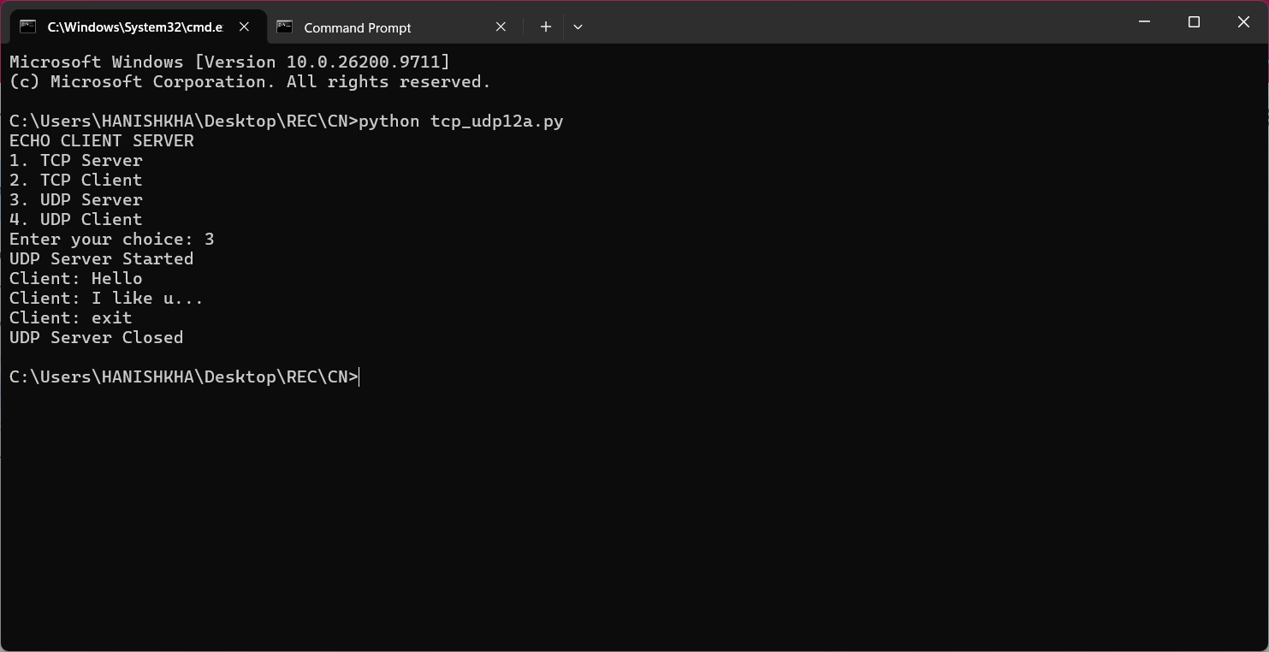
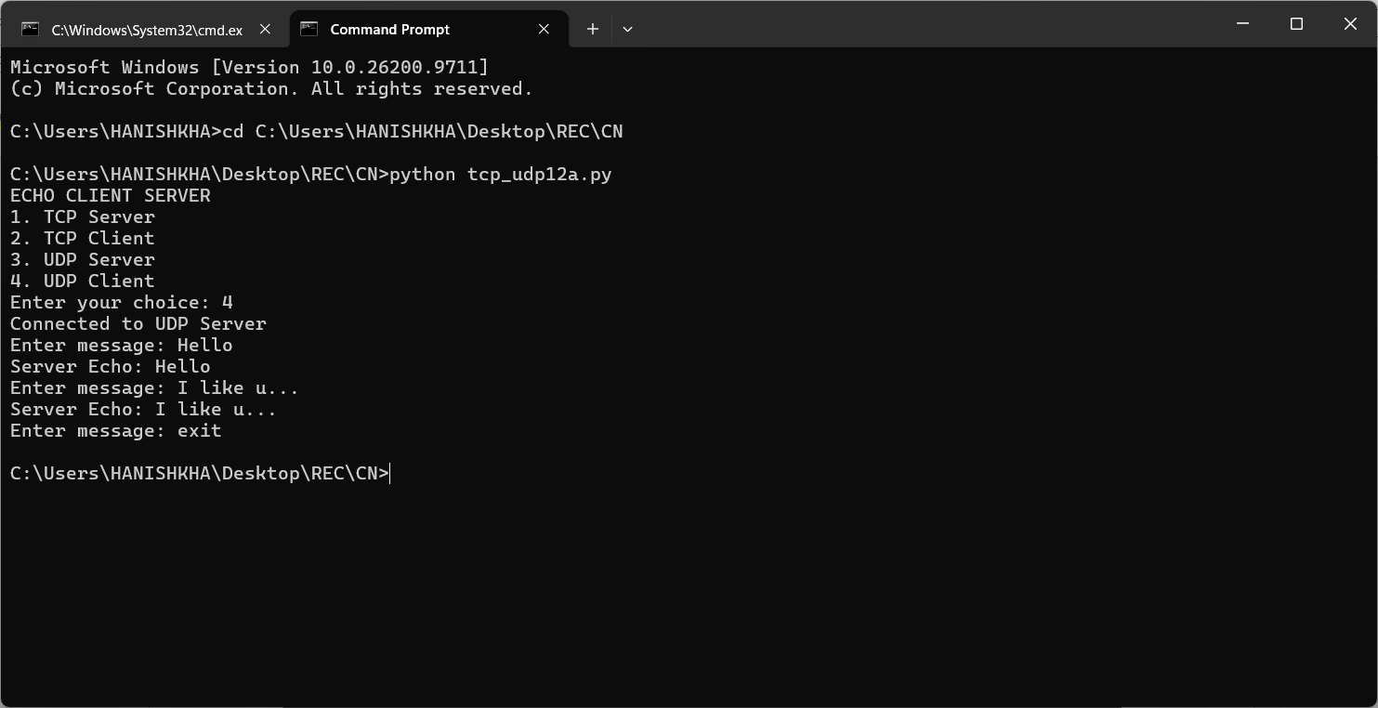
- Implement a chat program using socket programming.
AIM: To Implement a chat program using socket programming.
Program:
import socket
import threading
import sys

HOST = '127.0.0.1'
PORT = 12355

def receive_messages(sock):
"""Continuously listens for incoming messages from the peer."""
while True:
try:
data = sock.recv(1024)
if not data:
print("\n[Connection closed by remote peer]")
break
print(f"\nPeer: {data.decode()}")
print("You: ", end="", flush=True)
except:
break

def run_server():
server = socket.socket(socket.AF_INET, socket.SOCK_STREAM)
server.bind((HOST, PORT))
server.listen(1)
print(f"[Chat Server] Listening on {HOST}:{PORT}...")

conn, addr = server.accept()
print(f"[Chat Server] Connected with {addr}")
print("Type your messages below (type 'exit' to quit):\n")

# Start a background thread to receive messages concurrently
threading.Thread(target=receive_messages, args=(conn,), daemon=True).start()

try:
while True:
message = input("You: ")
conn.send(message.encode())
if message.lower() == 'exit':
break
finally:
conn.close()
server.close()
print("[Chat Server] Closed.")

def run_client():
client = socket.socket(socket.AF_INET, socket.SOCK_STREAM)
try:
client.connect((HOST, PORT))
except ConnectionRefusedError:
print("[Error] Could not connect to chat server. Is the server running?")
return

print(f"[Chat Client] Connected to server at {HOST}:{PORT}")
print("Type your messages below (type 'exit' to quit):\n")

# Start a background thread to receive messages concurrently
threading.Thread(target=receive_messages, args=(client,), daemon=True).start()

try:
while True:
message = input("You: ")
client.send(message.encode())
if message.lower() == 'exit':
break
finally:
client.client_socket = client.close()
print("[Chat Client] Closed.")

def main():
print("=" * 45)
print(" TCP REAL-TIME CHAT PROGRAM ")
print("=" * 45)
print("1. Start Chat Server")
print("2. Connect as Chat Client")
print("-" * 45)
choice = input("Select an option (1-2): ").strip()

if choice == '1':
run_server()
elif choice == '2':
run_client()
else:
print("[Error] Invalid choice.")

if __name__ == "__main__":
main()
Output:


